**The Mysterious Maya**

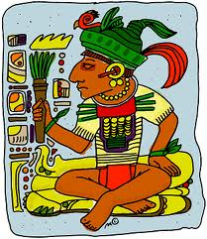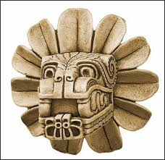

|  |
| --- |
| A long time ago, around 2500 BCE, an ancient tribe of Central American Indians called the Olmecs settled in the rainforests of the Yucatan Peninsula of Central America.  About two thousand years later, around 400 BCE, a new people suddenly appeared. These people were called the Maya. No one knows where they came from, but they arrived with amazing skills. They were an advanced civilization. They soon took over the Yucatan Peninsula of Central America.  The Maya were very clever people. Their system of mathematics was among the most sophisticated in the ancient world. Like the ancient Romans, the Mayas were master builders. Unlike the ancient Romans, the ancient Mayas did not have metal tools. Their tools were made of stone, bone, and wood. Yet they built beautiful structures, huge cities, and excellent roads - roads that connected the many hundreds of cities that made up the Maya world.  Around 900 CE, the Maya cities were abandoned. A few people continued to live in the cities, but mostly, the cities were empty. The people had, for the most part, disappeared, gone somewhere else.  Those who remained were unable or unwilling to repair the magnificent roads and buildings. The great Maya cities fell into ruin.  To this day, nobody knows where the Maya people came from before they arrived in the Yucatan Peninsula, and nobody knows why they left or where they went when most of the Maya people abandoned their cities and disappeared from the Yucatan Peninsula. That's why the Maya are sometimes referred to as "the mysterious Mayas".  During the 1500 years or so that the Maya Indians made their home in Central America, they build hundreds of religious centers, each filled with huge pyramids and  elaborate temples. There was at least one ball court in every city. Excellent roads ran for miles through the jungles and swamps, linking these centers of religion and learning.  Today, archaeologists remain very curious about these ancient people. Archaeologists face many dangers to hunt for the ruins of the ancient Maya cities hidden deep in the jungles of Central America.  There are not many, but there are some Maya people still living in Central America, descendants of the ancient Mayas who remained behind in the nearly deserted cities. Still today, their crafts are amongst the most beautiful in the world. |

Source: http://www.mayas.mrdonn.org/empire.html