Social Studies
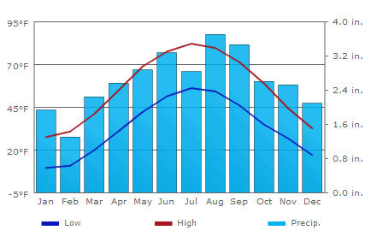Mrs. Wardell
Climate Graph of Gladwin, MI

Using your climate graphs of Buenos Aires, Argentina, and La Paz, Bolivia, complete the following questions:
- Compare the average high temperatures in Buenos Aires to La Paz. What are the major differences? Why do you think that is?

- Compare the average precipitation in Buenos Aires to La Paz. What are the major differences? Why do you think that is?

- Compare the climate graphs of Buenos Aires and La Paz to the climate graph of Gladwin above. What are the major differences? Why do you think that is?

