Social Studies Name: _________________________
Mrs. Wardell Hour: _______________

Canada Study Guide

Your Canada test will consist of multiple choice questions, short answers, and a map. Your test is worth 50 points. For your test, study from the following things:

Chapter 3 in your textbook
Canadian Symbols handout
Inuit Culture, Traditions, and History handout
The Igloo handout
Canadian Regions notes
French and British in Canada handout
Canadian Government packet
Study Guide
-------------------------------------------------------------------------------------------------------------------------------
- Define plural society:

- Define ecumene:

- Define rural:

- Define urban:

- Where is the ecumene found?

- 8 out of 10 Canadians live in an ______________ area.

- Most of Canada’s people live within __________ miles of the U.S.

- Canada is the ____________ largest country in the world.

- Canada’s population in 2001 was just over __________ million people.

- Who are Canada’s three “Founding Peoples”? Why?

- 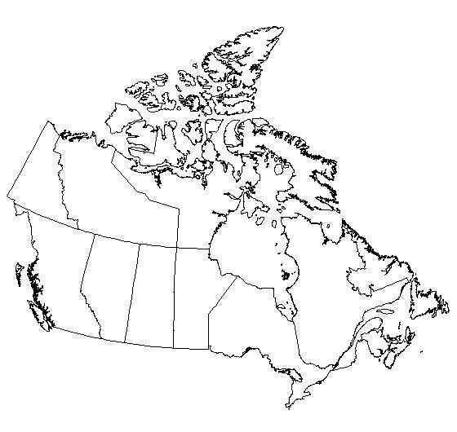 Label Canada’s 5 regions:

- Be able to explain each region in terms of language, population, climate, buildings, and economic activity (that means study your Canadian region notes!). For example, be prepared to answer questions such as: Which group influenced the buildings in the Pacific Region? Which region has the majority of Canada’s population?

- Why is the beaver one of Canada’s national symbols?

- Why is the maple leaf one of Canada’s national symbols?

- Why is the inuksuk one of Canada’s national symbols?

- Who are the Inuit?

- What two things influence the traditional Inuit way of life?

- Where are Inuit communities located?

- What does the word Inuit mean?

- What is the name of the Inuit language?

- Describe what a tundra looks like:

- What do Inuits use to build their homes?

- What did they use for travel?

- What does the Inuit diet consist of?

- Traditional Inuit clothing was made from:

- What are important traditions that continue in the Inuit culture today?

- How quickly can one Inuit man build an igloo?

- Why do igloos have a tunnel?

- Why are the sleeping areas always higher than the other areas in an igloo?

- How many types of igloos are there in general?

- What is the smallest of the igloos used for?

- The largest of the igloos can have up to _______ rooms and up to __________ people living inside it.

- The large igloos might consist of plenty of small igloos ________________ together.

- Besides living in, what other things are large igloos used for?

- This group of Europeans originally settled in Canada:

- What major city did the French start?

- This river was the natural highway into Canada and the Great Lakes region:

- Who did the French go to war with in the mid 1700s? WHY?

- Who won the French and Indian War?

- Why did the British allow the French to continue to occupy Canada after the war?

- Rather than states, Canada has these:

- How many provinces does Canada have?

- How many territories does Canada have?

- What’s the difference between a province and a territory?

- Who makes the laws in Canada?

- Rather than a president, Canada has a:

- What is the capital of Canada?

- Be able to compare/contrast the U.S. and Canadian governments:

- Be able to explain how climate affected Inuit culture:

