Social Studies Name: _______________________
Mrs. Brown Hour: ____________

Origins of Government
Theories on the origin of governments:

Force  Theory | Believes governments started with the strongest person taking control by force | 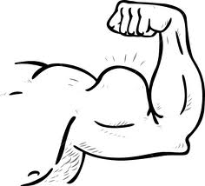
Evolutionary Theory | Believes government structure started in the home, spread into the communities, and then wider into developing a country | 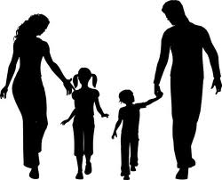
Divine  Right Theory | Believes certain people thought they and their families were blessed and ordained by God as special and therefore should rule over others | 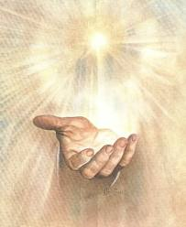
Social Contract Theory | Believes people give up certain selfish rights in order to do what is best for society by “contracting” with each other to be governed

Types of Government
The type of government depends upon how power is divided, and how many (if any) limits are on the government.
Governments can be classified into several types. Some of the more common types of governments are:
1. Democracy
The word "democracy" literally means "rule by the people." In a democracy, the people govern directly.
2. Republic
A literal democracy is impossible in a political system containing more than a few people. All "democracies" are really republics. In a republic, the people elect representatives to make and enforce laws.
3. Monarchy
A monarchy consists of rule by a king or queen. Sometimes a king is called an "emperor," especially if there is a large empire, such as China before 1911. There are no large monarchies today. The United Kingdom, which has a queen, is really a constitutional monarchy because the queen has virtually no political power.
4. Aristocracy
An aristocracy is rule by the aristocrats. Aristocrats are typically wealthy, educated people. Many monarchies have really been ruled by aristocrats. Today, typically, the term "aristocracy" is used negatively to accuse a republic of being dominated by rich people, such as saying, "The United States has become an aristocracy."
5. Dictatorship
A dictatorship consists of rule by one person or a group of people. Very few dictators admit they are dictators; they almost always claim to be leaders of democracies. The dictator may be one person, such as Castro in Cuba or Hitler in Germany, or a group of people, such as the Communist Party in China.
6. Democratic Republic
Usually, a "democratic republic" is not democratic and is not a republic. A government that officially calls itself a "democratic republic" is usually a dictatorship. Communist dictatorships have been especially prone to use this term. For example, the official name of North Vietnam was "The Democratic Republic of Vietnam." China uses a variant, "The People's Republic of China."

Social Studies Name: _______________________
Mrs. Brown Hour: ____________

Origins of Government
Theories on the origin of governments:

Force
Theory

Believes government structure started in the home, spread into the communities, and then wider into developing a country
Divine
Right Theory

Believes people give up certain selfish rights in order to do what is best for society by “contracting” with each other to be governed

Types of Government
The type of government depends upon how power is divided, and how many (if any) limits are on the government.
Governments can be classified into several types. Some of the more common types of governments are:
1. _________________________________________
The word "democracy" literally means "rule by the people." In a democracy, the people govern directly.
2. _________________________________________
A literal democracy is impossible in a political system containing more than a few people. All "democracies" are really republics. In a republic, the people elect representatives to make and enforce laws.
3. _________________________________________
A monarchy consists of rule by a king or queen. Sometimes a king is called an "emperor," especially if there is a large empire, such as China before 1911. There are no large monarchies today. The United Kingdom, which has a queen, is really a constitutional monarchy because the queen has virtually no political power.
4. _________________________________________
An aristocracy is rule by the aristocrats. Aristocrats are typically wealthy, educated people. Many monarchies have really been ruled by aristocrats. Today, typically, the term "aristocracy" is used negatively to accuse a republic of being dominated by rich people, such as saying, "The United States has become an aristocracy."
5. _________________________________________
A dictatorship consists of rule by one person or a group of people. Very few dictators admit they are dictators; they almost always claim to be leaders of democracies. The dictator may be one person, such as Castro in Cuba or Hitler in Germany, or a group of people, such as the Communist Party in China.
6. _________________________________________
Usually, a "democratic republic" is not democratic and is not a republic. A government that officially calls itself a "democratic republic" is usually a dictatorship. Communist dictatorships have been especially prone to use this term. For example, the official name of North Vietnam was "The Democratic Republic of Vietnam." China uses a variant, "The People's Republic of China."

