Characteristics of a Map Notes

- Title
Gives our first clue about the content like the area shown and the main topic

Sometimes the title lists a date, which tells what the map shows at a certain time

- Compass Rose
Compass Rose-a diagram that shows us directions.

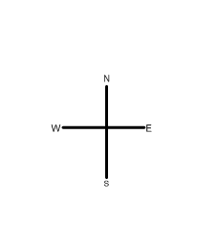
Why is it called a compass rose? On early maps, the diagram was often drawn like a flower. There are two kinds of compass roses:

Cardinal directions: A simple compass rose
that has north, south, east, and west. These
four directions are called cardinal directions.
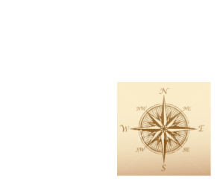
Intermediate directions: This rose has lines between the cardinal points. These show
northeast, southeast, southwest, and northwest. These directions are called intermediate
directions.

- Legend
Legend-Symbols are used to show information on a map. They use color and pictures to show the locations of particular things, like airports and state capitals. There is a box where the symbols are listed with what they mean, called a map legend or map key.
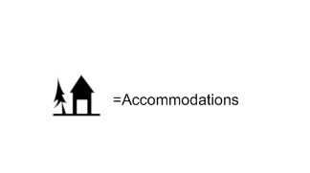

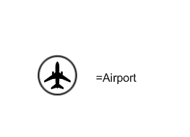
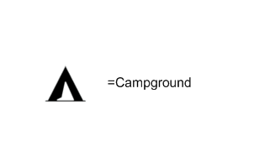

- Grid
Grid-a system of imaginary lines to divide up space on their maps.

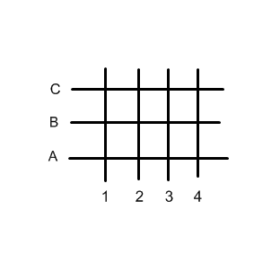
Geographers make map grids useful by giving each line a label. On some maps horizontal lines have letters, and vertical lines have numbers. Once the grid is labeled, the location of any place on the map can be indicated by a letter and number:

One very useful grid is the system of latitude and longitude. This global grid allows you to locate any place on Earth with a simple number code.

